High Level Design (LLD)

INVESTMENT PREDICTIONS

RITESH RAJURKAR

**Abstract**

Stock market plays a pivotal role in financial aspect of the nation's growth, but stock market is highly volatile and complex in nature. It is affected by significant political issues, analyst calls, news articles , company's future plans of expansions and growth and many more. Hence, any investor would be interested in understanding the stock market overtime and how the factors mentioned above affect the behavior of the stock market. On Every business day, millions of traders invest in stock market. Most of these investors lose money and others gain. However, considering any trading day, loss or gain is absolutely inconsistent. The demand to predict stock prices are extremely high, hence is the need for stock market analysis. This project is focused on analyzing a stock of any given company based on statistical technical indicators. Some of these indicators are deterministic in nature and the remaining are probabilistic. The objective of this project is to minimize the risk of loss in every trade thereby maximizing the profit.

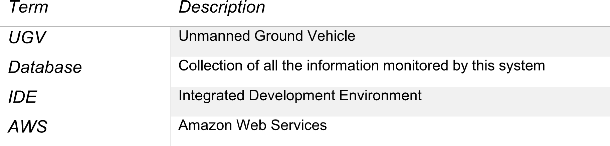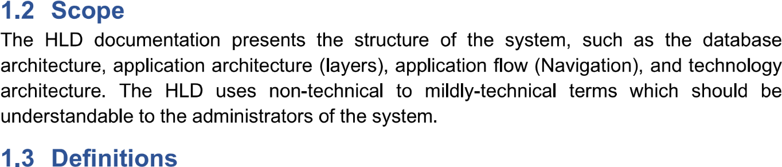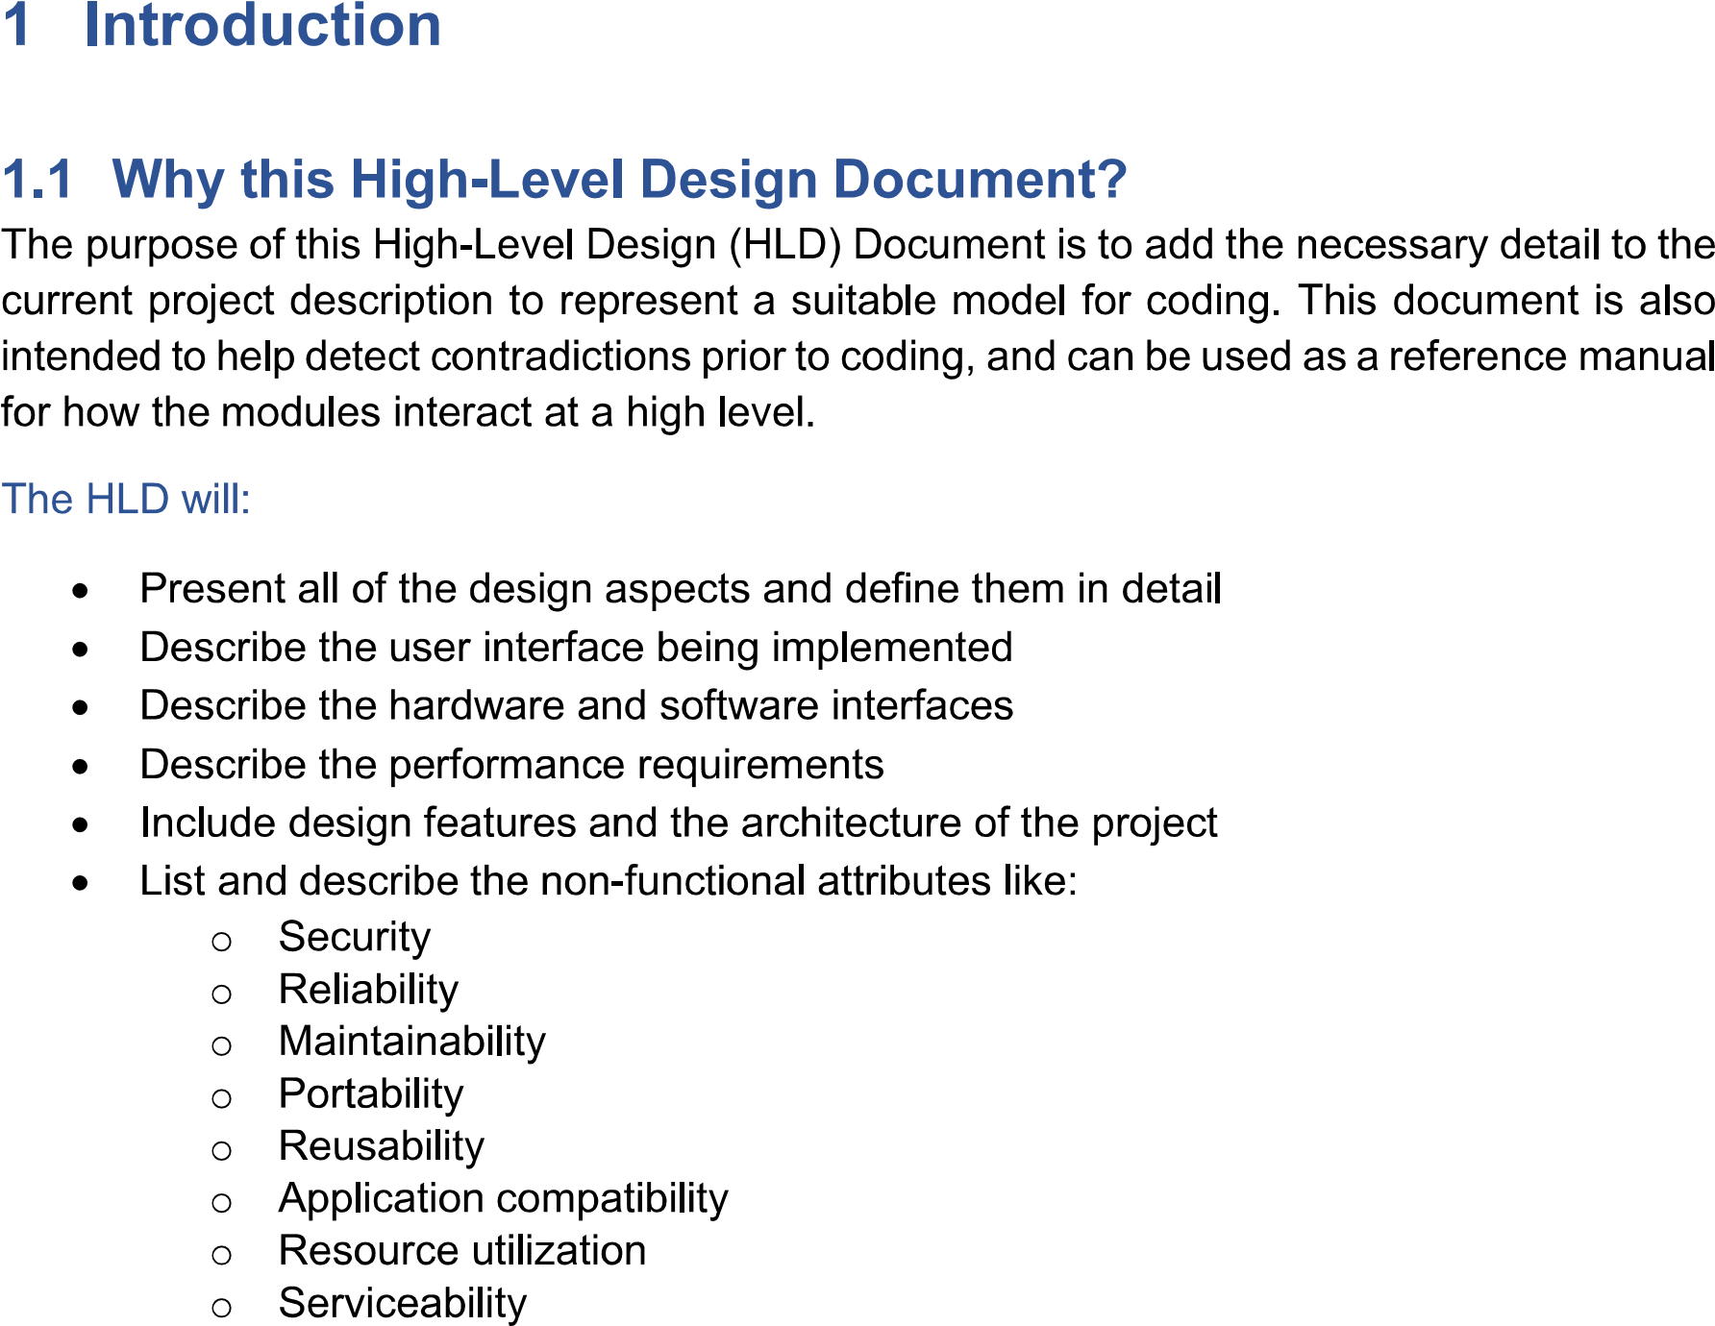

**2. General Description**

**2.1 Product Perspective**

Investment prediction is a machine learning prediction model will help us to predict the stock market rate, stock changes, stock ath and atl.

**2.2 Problem statement**

To create an investment prediction model for stock market prediction and to implement to following cases.

1. Aim to determine the future movement of the stock value of a financial exchange.
2. Aim to predict the trend of stock price in the stock market.

**2.3 Technical Requirement**

This document address the requirements for detecting the stock prediction in the stock market and recommending the necessary actions to detect the false trend.

**2.4 Data Requirement**

Data Requirement completely depend upon problem statement.

* We need data that is balanced and must have more than 1000 stocks.

Dataset consist of different different features:

* Date
* Open
* High
* Low
* Close
* Adjclose
* Volume

Date: The Date is used for the date time of stock price and listing.

Open: The open is the starting period of trading on a securities exchange or organized ever the counter market

High: The high Is the highest trading price in the stock market exchange.

Low: The low is the lowest price in the stock market exchange.

Close: The close is a reference to the end of a trading session in the financial markets when the markets close for the day.

Adjclose: The adjusted closing price amends a stock’s closing price to reflect that stock’s value after accounting for any corporate actions.

Volume: Volume measures the number of shares traded in a stock market traded in futures or options.

**2.4 Tools Used**

Python programming language and frameworks such as NumPy, Pandas, Scikit-learn, Tensorflow, keras are used to build the whole model.

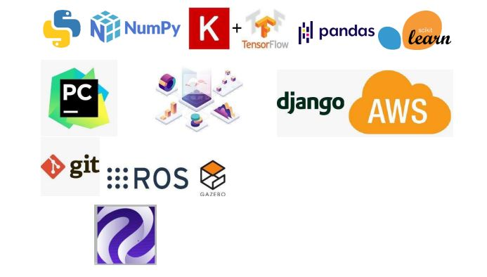

1. **Design Details**

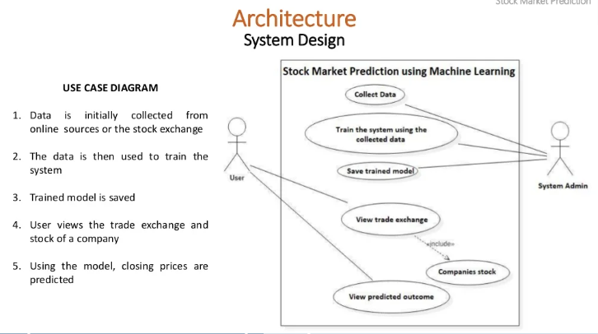

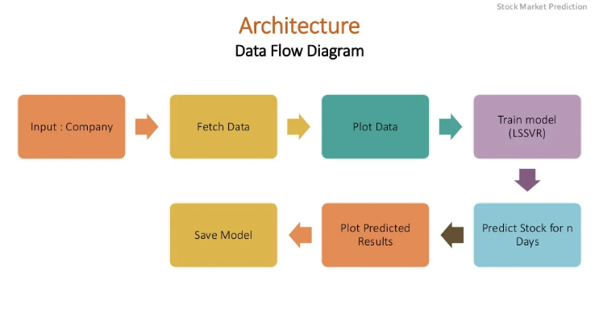

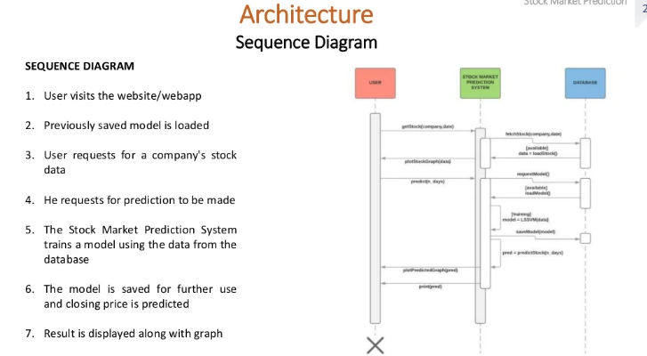

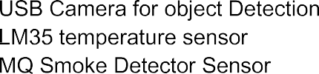Hardware Requirements

